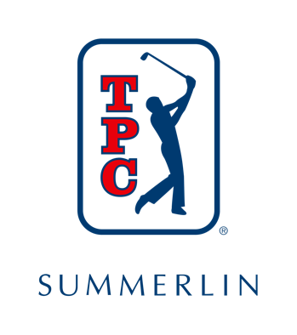
For Immediate Release For More Media Information:
The Zimmerman Agency
tpcpr@zimmerman.com

TPC SUMMERLIN’S DALE HAHN
ELECTED TO LAS VEGAS GOLF HALL OF FAME

LAS VEGAS – July 12, 2022 – TPC Summerlin, a private 18-hole golf course located just minutes from the famed Las Vegas Strip and host to the PGA TOUR’s Shriners Children's Open, congratulates Dale Hahn, Director of Golf Course Maintenance Operations on being selected to join the 2022 Class of the Las Vegas Golf Hall of Fame.

The Las Vegas Golf Hall of Fame is set to induct Hahn on October 1 at TPC Summerlin as the official kickoff for the PGA TOUR’s Shriners Children’s Open taking place Oct. 3-9, 2022.

“I’m honored to be elected to join such a prestigious group of trailblazers in the golf industry,” said Hahn. “This is an achievement of a lifetime, and I am very appreciative of the opportunities provided to me through my role at TPC Summerlin.”

Before joining TPC Summerlin, Hahn was the superintendent at Morgan Run and Pala Mesa Resorts. Those experiences have helped shape his passion for agronomy, leading to a successful career at TPC Summerlin, overseeing renovations along with tournaments and preparing the course for valued members and TOUR players.

“We’re so lucky to have had someone like Dale lead our agronomy team for the past two decades,” said Brian Hawthorne, TPC Summerlin’s General Manager. “He’s extremely deserving of being elected to the Las Vegas Golf Hall of Fame and has been vital to the operations here at TPC Summerlin.”

Since 1991, the Las Vegas Hall of Fame has inducted 61 members - of those, 13 were club professionals and two were golf course superintendents. For this year’s Class of 2022, Hahn was selected out of 80 individuals and organizations in Las Vegas by the Hall of Fame selection committee who meets six times a year to have open discussions about each nominee and their impact on the community.

“We don’t want to award someone for just doing their job,” said Joe Kelly, President of the Las Vegas Golf Hall of Fame. “We want to honor individuals that do an outstanding job, making a difference in the community outside of work and are involved in their organization. We are pleased to honor someone whose golf facility is proud to have them represent their club and Dale Hahn checks all those boxes.”

To learn more about TPC Summerlin, please visit www.tpc.com/summerlin.

###

About TPC Summerlin
Named by Golf Digest as “One of America’s Best Golf Courses,” TPC Summerlin and its championship layout continue to redefine the private golf club membership experience in Las Vegas. The par-72, 7,243-yard golf course’s layout was carved from a magnificent swath of rugged desert terrain by renowned golf course architect Bobby Weed which meanders through arroyos and canyons, with striking flora, numerous water features, an abundance of honey mesquite and pine trees contrasting dramatically with undisturbed desert washes – creating one of the most visually stunning tests of golf in Nevada. TPC Summerlin’s golf, amenities and exceptional member benefits make it one of the most coveted private clubs in Nevada where members enjoy a sense of community, camaraderie and belonging that come with participation in exclusive members-only golf and social events throughout the year.

About the TPC Network
Owned, operated, and licensed by the PGA TOUR, the TPC Network is comprised of 30 premier private, resort and daily fee golf properties designed by some of golf’s most elite architects. Seventeen of the clubs are operated by affiliates of PGA TOUR Golf Course Properties, Inc. Each TPC has hosted or has been designed to host TOUR-sponsored golf tournaments. Since TPC Sawgrass first opened its world-renowned PLAYERS Stadium Course in the fall of 1980, TPCs have provided the PGA TOUR with rent-free venues for tournaments, helping to boost championship golf purses and increasing charitable donations to grass roots non-profit organizations. At the same time, TPCs have provided recreational golfers with the unique opportunity to test their skills on the same layouts where the world’s best golfers compete.

TPCs are known for their history of hosting PGA TOUR-sponsored golf tournaments, their outstanding conditioning and amenities, as well as a commitment to environmental excellence. The TPC Network is also distinguished by its unwavering commitment to further the PGA TOUR’s giving back mission through support of charitable and grass-roots programs. For more information, please visit www.tpc.com. For the most up-to-date news, follow the TPC Network on Twitter (@PlayTPC), Instagram (@PlayTPC) or Facebook.com/TPCNetwork.

